Submitted by : M. Abdullah Azam
Register Number : SP24-BSE-034
Submitted to : Ms. Ambreen Gul
Date of Submission : 14/10/2025
Course : Information Security

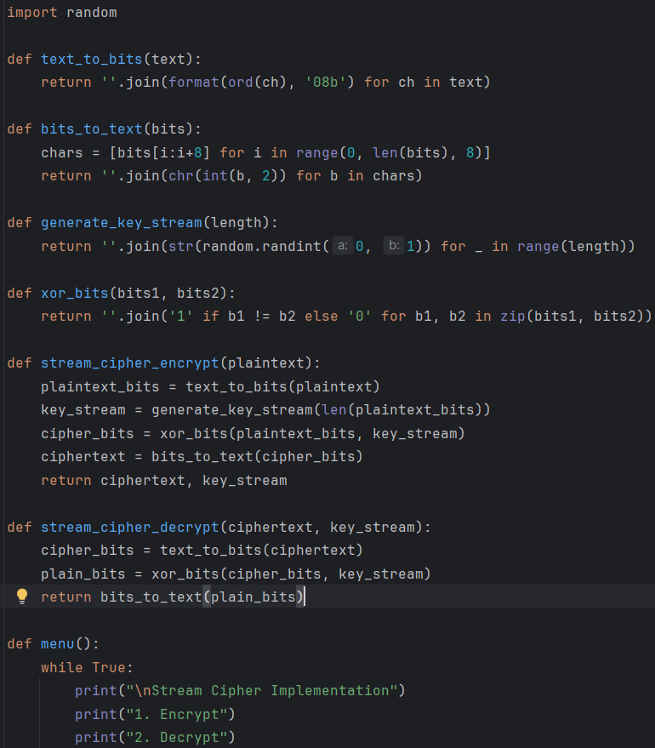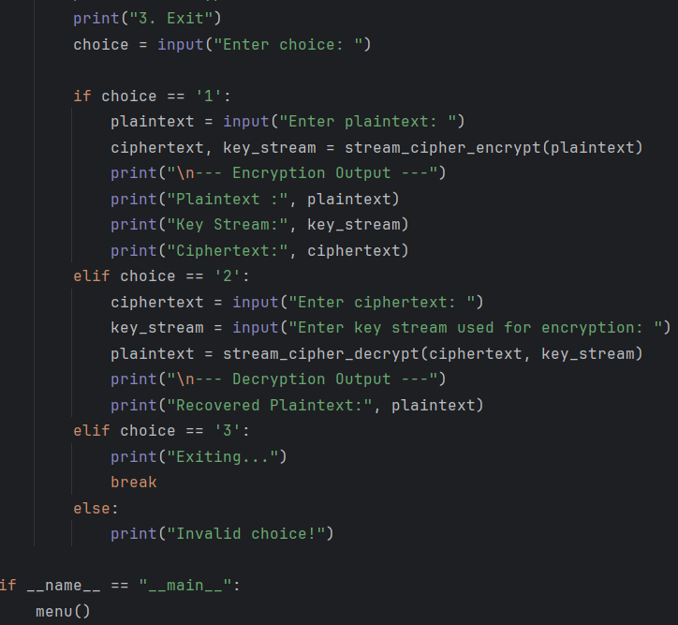

OUTPUT
